Instructions for Smith Hall Classrooms
This will send the system back to the password screen.
These control what the projector displays.
Choose the source you want shown to the class here.

When you first enter the classroom the screen will likely be blank. Touch the screen to wake it up. You will then see the logo screen on the right. Touch anywhere on this screen.

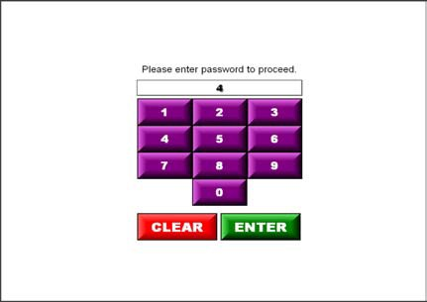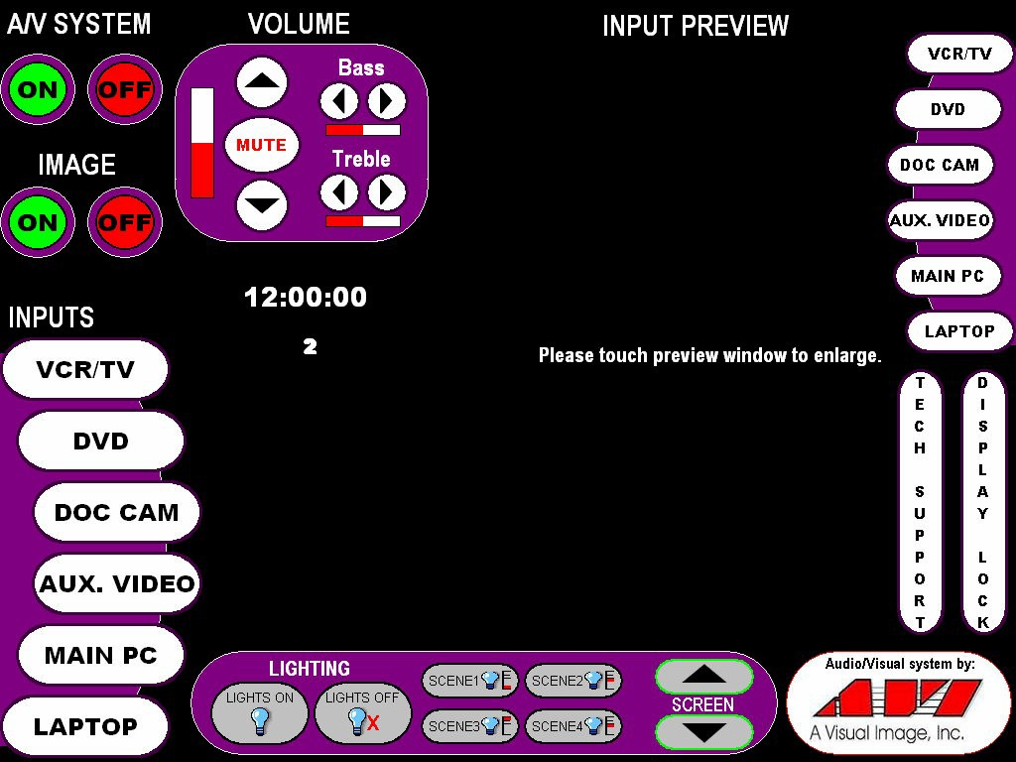You will then be prompted for a password. Enter the numerical password using the number pad provided on the screen. Touch enter after you have put in the password.
This controls what you see on this screen. Touch the buttons to choose the source. Touch the image to enlarge to full screen
These control the sound. The system will turn on Muted. If you want sound you will have to hit the Mute button
This will turn the projector on and bring the screen down

These control the lights. Scene 1 comes on as the default when you start to project something. Choose from the others here.

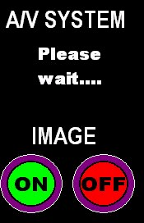
When you first turn the system on the ON/OFF buttons will be replaced by a Please wait… message. This is giving the system time to warm up. You will not be able to turn the system off until it is done warming up.

The Image ON/OFF is essentially a mute button for the projector. Touching OFF will make the projector stop projecting without turning it off completely and Touching ON will bring your image back up.

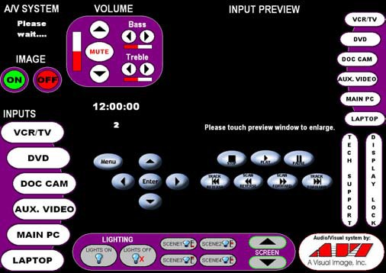
When you choose DVD from the Input list or from the Preview list, the screen will provide controllers for the DVD player in the center of the screen.

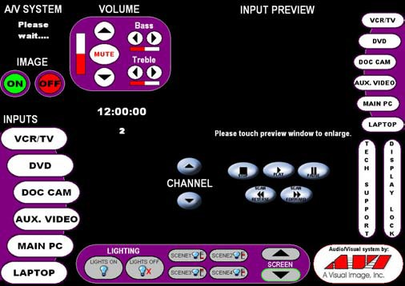
Likewise, when you choose VCR from the Input or Preview lists you will be given controls for channel selection and VHS tape controls.

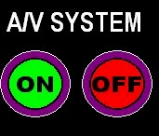
REMEMBER: By default when the system is turned on, the Mute will be on. To hear your tape, DVD or cable channel you will need to unmute the volume.

When you leave the classroom LOG OFF from the computer (if used) and then hit the red A/V system OFF button.

